A Hybrid Deep Learning Model for Arabic Text Recognition

Mohammad Fasha
Amman, Jordan, mohd.fasha@gmail.com
Bassam Hammo
King Abdullah II School for Information Technology, The University of Jordan, Amman, Jordan, b.hammo@ju.edu.jo
Nadim Obeid
King Abdullah II School for Information Technology, The University of Jordan, Amman, Jordan, nadim@ju.edu.jo
Jabir al Widyan
Princess Sumayah School for Technology, Amman, Jordan, j.alwidian@psut.edu.jo

Abstract
Arabic text recognition is a challenging task because of the cursive nature of Arabic writing system, its joint writing scheme, large number of ligatures and many others. Deep Learning (DL) paradigm achieved significant progress in numerous domains including computer vision and sequence modelling. In this paper, we examine a model that employs a hybrid DL network to recognize Arabic text that is printed using multiple font types including the ones that mimic handwritten scripts. The model operates in an end-to-end fashion and does not require character segmentation. We tested the model on a custom dataset comprises over two million word samples generated using (18) different font types. The model achieved good results in Character Recognition Rate (CRR) and Words Recognition Rate (WRR). The model also achieved promising CRR results when tested with unseen data.
CCS CONCEPTS
• Computing Methodologies • Artificial Intelligence • Natural Language Processing
KEYWORDS
Arabic OCR, RCNN, Multi-Font Text Recognition.
- Introduction
Optical Character Recognition (OCR) is the process of recognizing text in images and transforming it into a machine encoded text. OCR is an important research area and generally, it can be classified into two main groups, online OCR and offline OCR. Online OCR involves recognizing text while typing in real time such as recognizing digital stylus writing on mobile phones, while offline OCR involves the recognition of text in document images such as scanned documents archives, printed application forms, bank cheques, postal mail and many others. In addition, OCR addresses two main categories of text; machine printed text and handwritten text and each of these two areas has its own challenges. Printed text is faced with the diversity of font types and formatting styles as well as printing and scanning quality, while handwritten text is considered more challenging because of the diverse writing styles of individuals.
Recognizing Arabic text in images has additional challenges. These challenges are mainly driven by the cursive nature of Arabic script. In addition, Arabic characters are connected in words, and the writing system has a large number of ligatures, which increase the challenge of recognizing text based on characters boundaries. Further, the scarcity of labelled datasets for Arabic language increases the challenges of developing new solutions that depend on supervised learning models.
In this work, we examine a model that employs a hybrid DL network to recognize multiple font types including the ones that mimic handwritten scripts in printed Arabic text. The hybrid DL model uses a Convolution Neural Network (CNN) and a Bi-Directional Short Long Term Memory network (BDLSTM) and it operates in an end-to-end fashion without the need for character segmentation.
To test the performance of the model, we compiled a custom dataset made of (18) different fonts types collected from online sources. The selected fonts were chosen because they exhibit high cursive nature that mimics Arabic handwriting styles. The dataset was extracted from Arabic Wikipedia Dump and it contains over two million words samples.
We conducted several experiments to examine the model’s performance and to assess its generalization capabilities. Despite being a moderate model in terms of its complexity (i.e. it can be trained on a single CPU), the same model was able to achieved (98.76%) in Character Recognition Rate (CRR) and (90.22%) in Words Recognition Rate (WRR) for all the tested font types. However, the model demonstrated degradation in its performance when we tested on an unseen dataset or noisy images. In the case of unseen dataset, it achieved a CRR success rate of (85.15%), while in the case of noisy images it achieved a CRR success rate of (77.29%). However, resolving these issues require additional investigations, which are out of the scope of this work.
The remaining of the paper is organized as follows: In section ‎2, we present an overview of the related work. In section ‎3, we discuss the challenges related to Arabic text recognition. In section ‎4, we present the compiled dataset. In section ‎0, we discuss the proposed model in details. Section ‎6 presents the experiments and obtained results. Finally, section ‎7 concludes the paper and identify some future research avenues.
- Related Word
The recognition of Arabic text is still a challenging task because of many intricate features related to the nature of Arabic writing system (Ashraf A. Shahin.2017). Work in this domain is an active research area where many models are continuously proposed for the problem of automatically recognizing printed or handwritten text. Each domain has its own challenges and requirements. The challenges of recognizing printed Arabic text are driven by the need for a ubiquitous model that can efficiently recognize Arabic text that is printed using multiple font types and formatting styles. On the other hand, the challenges facing the handwritten Arabic text are driven by its high variety due to the diversity of individuals writing styles. In this section, we present an overview on the related recent work in both domains and the methods that have been employed to recognize text.
A recent model for recognizing printed Arabic characters in isolation mode was presented in (Aboul Ella Hassanien, Mohamed F. Tolba, and Ahmad Taher Azar.2014). The proposed model applied the K-Nearest Neighbor (KNN) and Random Forest Tree (RFT) algorithms to recognize Arabic text. The model used statistical methods to extract features from text images. These features included the dimensions of the text shape, pixels transitions, number of black vs white pixels, and regional ratios of pixel values. The KNN classifier achieved a successful rate of (98%), while the RFT classifier achieved (87%). Similarly, the authors in (Ashraf A. Shahin.2017) introduced a model for recognizing Arabic printed text using linear and nonlinear regression. In their work, text in images is initially thinned and segmented into sub words. Relations between word segments were represented using a numerical coding scheme. The coding scheme was used to represent characters as a sequence of points, lines, ellipses and curves. A unique code was established for each character form and a unique list of codes were used to recognize each font type. Linear regression was used to validate the representations against a ground truth table using distance measures. The model was evaluated using (14000) words samples and it has achieved an accuracy rate of (86%).
In (Abdelhay Zoizou, Arsalane Zarghili, and Ilham Chaker.2018), the authors proposed a model for segmenting Arabic printed text that can serve as a preliminary step in text recognition. The model used contours analysis and template matching techniques. The contour segmentation was determined by the local minima values of the contour and the template-based technique involved scanning the black pixels positions after segmenting the text into lines and sub words using horizontal and vertical projections. A custom multi-font corpus was prepared to evaluate the model, which was evaluated against five similar methods. The model achieved an enhanced accuracy over the other models with a score of (94.74%).
Arabic text recognition research was also influenced by the progress that was achieved by the advancement of the deep learning technology. Earliest work in implementing DL approaches to Arabic text recognition can be traced back to (Alex Graves.2008). In that work, a Multi-Dimensional Long Short Memory (MDLSTM) network and Connectionist Temporal Loss (CTC) were used to recognize Arabic text in images. The model was tested on the IFN/ENIT dataset of handwritten Tunisian Town names (Mario Pechwitz, Samia Snoussi, and Noureddine Ellouze.2002) and an accuracy levels of (91.4%) were reported.
A more recent work in the field of Arabic text recognition using DL models was carried out by (Hanan Alahmad Bodour Alreha,Najla Alsaedi.2020). The domain of their work was the recognition of Arabic script in historical Islamic manuscripts. The presented model used various preprocessing techniques to enhance the quality of the scanned images and to segment the text prior to the recognition process. CNNs were used to recognize the preprocessed text and accuracy levels ranging from (74.29%) to (88.20%) were reported.
In (Ali Mohsin and Mohammed Sadoon.2019), a model for recognizing Arabic handwritten text using neural networks was presented. Initially, the noise in images was reduced using multiple image preprocessing techniques. The characters in words were segmented into regions using a threshold-based method and these regions were used to construct feature vectors. The model was examined on a custom dataset collected from volunteered writers and a CRR of (83%) was reported. Similarly, the work of (Khaled Younis and Abdullah Khateeb.2017) presented a three-layers CNN model for recognizing Arabic handwritten characters in isolated model. The model was examined on AIA9k (Marwan Torki, Mohamed E. Hussein, Ahmed Elsallamy, Mahmoud Fayyaz, and Shehab Yaser.2014) and AHCD (Hazem EL-Bakry Ahmed El-Sawy, Mohamed Loey.2017) datasets and CRR of (97.6%) was reported. In (Andreas Dengel Riaz Ahmad, Saeeda Naz, Muhammad Afzal, Sheikh Rashid, Marcus Liwicki.2017), the authors presented a DL based model for recognizing handwritten Arabic text using a MDLSTM network and CTC loss function. The objective was to compare the performance of their proposed model against similar models after extending the dataset using data augmentation techniques. The KHAT handwritten dataset (Sabri A. Mahmoud, Irfan Ahmad, Mohammad Alshayeb, Wasfi G. Al-Khatib, Mohammad Tanvir Parvez, Gernot A. Fink, Volker Märgner, and Haikal El Abed.2012) was used to train and evaluate the model and a CRR level of (80.02%) was reported. Finally, in (Mohit Jain, Minesh Mathew, and C. V. Jawahar.2018) a hybrid DL model for detecting printed Urdu text in scanned documents was presented. The model employed a hybrid combination of CNN and BDLSTM along with CTC loss. The model was tested on URDU and APTI datasets (Fouad Slimane, Slim Kanoun, Haikal El Abed, Adel M. Alimi, Rolf Ingold, and Jean Hennebert.2013) where it achieved CRR rates of (89.84%) and (98.80%) respectively.
Reviewing the related work revealed that there is a shortage in work that addresses printed Arabic text using DL models. Our work should present some contribution and set some footsteps in this research area.
- Challenges Related to Arabic Text Recognition
Arabic writing system is used by different nations around the world including the (21) Arab countries as well as other nations such as Kurdish, Pashto, Persian, Sindhi, Uighur and Urdu. The base writing system is made of the base alphabets of Arabic language, which consist of (28) alphabets and (10) Hindi format numerals. Nevertheless, the shape of Arabic alphabets can change according to its position in the word. Figure 1 shows the based alphabets of Arabic language as well as their variations according to their position in the word.
Arabic alphabets are written from right-to-left while the numbers are written from left-to-right. A main challenge related to Arabic writing system is due to its cursive nature while alphabets are written in a joint flowing style. Characters in Arabic script, whether handwritten, typed or printed are connected within words and they might overlap within the same word or across words (i.e. inter and intra overlapping). In addition, spaces can occur within words and across them. Various Arabic characters share the same main shape (e.g. ba, ta, tha as shown in Figure 1).
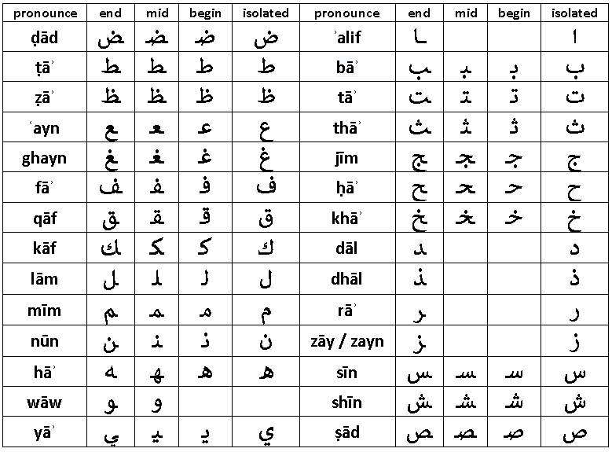
Figure 1: Arabic base alphabet
However, they are distinguished by the number of dots added under or above the base alphabet, which increase the challenge of identifying the correct alphabet. Further, the shapes of Arabic characters are represented using different glyphs according to the characters position in the word. Accordingly, different shapes are used when the character appears at the beginning, middle or at the end of a word.
Furthermore, the shape of Arabic characters in printed text varies depending on the used font, its formatting, and printing style. Besides, natural languages that use the Arabic writing system extends the base alphabets by adding special diacritics over some characters to better adapt the writing system to the phonemes of the designated language. A thorough discussing about these challenges can be found in (Mansoor Alghamdi and William Teahan.2018). All these characteristics make the recognition of Arabic text a challenging task, especially for the models that depend on segmenting characters prior to recognizing text (Andreas Dengel Riaz Ahmad, Saeeda Naz, Muhammad Afzal, Sheikh Rashid, Marcus Liwicki.2017).
The model we present in this work operates in an end-to-end fashion without the need for character segmentation, which facilitates the recognition process and increases its accuracy, as we will discuss in the forthcoming sections.
- The Compiled Dataset
During the last period, several Arabic printed datasets were introduced by the community including: DARPA, APTI , PATDB, APTID/MF, and RCATSS (Abdelhay Zoizou, Arsalane Zarghili, and Ilham Chaker.2018,Faten Kallel Jaiem, Slim Kanoun, Maher Khemakhem, Haikal El Abed, and Jihain Kardoun.2013,Fouad Slimane, Slim Kanoun, Haikal El Abed, Adel M. Alimi, Rolf Ingold, and Jean Hennebert.2013,Amin G. Al-Hashim and Sabri A. Mahmoud.2010,R Davidson, R., Hopely.1997). Nevertheless, there is no consensus on a standard dataset and the available datasets vary in their content types, sizes, formatting styles and fonts types (Alhomed and Jambi‏ 2018). A more thorough listing of similar datasets can be found in (Irfan Ahmed, Sabri A Mahmoud, and Mohammed Tanvir Parvez.2012). As stated earlier, the main target of this research is to recognize the fonts that exhibit printing styles that mimic Arabic hand writing forms in terms of the informality of characters shapes and their high cursive nature. Hence, we were not able to identify an available dataset that can support our target goal. Accordingly, we were opted to compile a number of custom synthetic datasets i.e. Arabic Multi-Fonts Dataset (AMFDS), using the (18) fonts depicted in Figure 2.
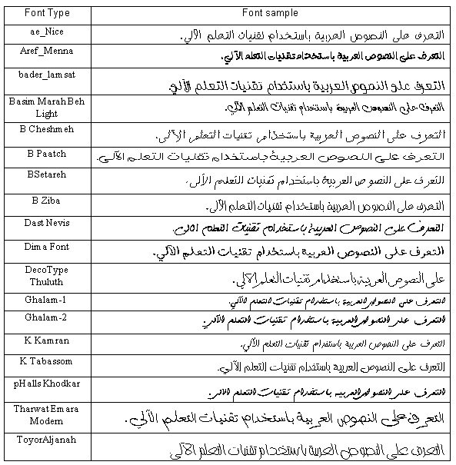
Figure 2: The set of the selected fonts
In order to compile the datasets, we developed a toolkit that can be used to generate any number of text image samples using different font types and formatting styles. The toolkit can be configured to generate samples as separate image files or as a single binary repository for all samples.
Table 1 shows the main characteristics of each generated sample set. We selected the (ae-Nice) font to generate the single font datasets. This font type was selected because its printing style clearly exhibits cursive structures that resemble Arabic hand writing script. Similarly, we selected the (ae-Nice) and the (K-Karman) font’s types to generate the two font’s datasets. Sample sets (4) and (5) in Table 1 were generated using the font types that were presented in Figure 2.
Table 1-The selected sample sets
Sample set # | Number of fonts | Number of samples | Duplicates in samples | Sample set size | Fonts
1 | 1 | 60,000 | Exist | 148MB | ae-Nice
2 | 1 | 120,000 | Exist | 295MB | ae-Nice
3 | 2 | 240,000 | Exist | 490MB | ae-Nice  K-Karman
4 | 18 | 2,160,000 | Exist | 6200 MB | The fonts shown in Figure 2
5 | 18 | 450,000 | Unique words | 1300MB | The fonts shown in Figure 2

The sample sets (1, 2, 3) in Table 1 include duplicate samples because the same set of words was used to generate samples for each font type. In addition, these datasets has minor redundancies within the samples of each font because words were randomly sampled from Arabic Wikipedia Dump and no filtering was applied. The datasets (4 and 5) in Table 1 are unique (disjoint) and a single word does not replicate across the entire dataset. The current version of the datasets contains words samples that have a length of (7 to 10) characters. All the words were generated using font size (26) and bold formatting style.
Further, each dataset is comprised of two main data files: labels files and binary files. The labels file is a text file that contains details about the word samples including the Arabic word represented in the image, font type, font style, font size and a value that represent the start index for that image in the binary file. Each image has a different storage size, which depends on the length of the word and its printing style. Therefore, the byte stream of the designated image starts at the start index and spans to a length equals to the image’s size (in bytes). The binary file represents a single repository for all the images in the set. Unlike the common adopted approaches of using single image file for each word sample, we can argue that our approach in following the proposed structure is more appropriate for addressing large data files with large number of samples. This arrangement is more scalable as it facilitates moving the dataset around different execution environments such as cloud based environments, and facilitates the processing of image data in terms of loading, preprocessing and training.
The datasets we used in our experiments are made publically available at , and the toolkit that can be used to generate different samples is made publically available at .
- The Proposed Model
In general, text recognition systems implement a number of tasks before recognizing text in images. These tasks can be classified into five main categories including: the normalizing of document images to enhance their quality, detecting text regions within a document and segmenting text accordingly, extracting useful features from text, implementing the recognition process and employing a post processing technique to enhance the accuracy of the results. The focus of this work is on the recognition process; while the other tasks are out of the current scope of this work and might be addressed in future research.
The design and the implementation of our model was based on the work presented in (Harald Scheidl.2011), where a hybrid NN was employed to recognize handwritten text in scanned historical documents. We employed the same methodology of (Harald Scheidl.2011) to test the ability of our model in recognizing different styles of Arabic printed text.
The proposed model has two main components; a Convolutional NN and a Recurrent NN. These networks are stacked together in an end-to-end fashion that can perform word-level recognition without character segmentation. Table 2 below the specifications of the used model. The filter sizes in the initial two layers of the CNN used a size of (5, 5) units, which extends the receptive field of the network in the early layers. The three remaining convolution layers in the network used a filter size of (3, 3). The convolution process implemented zero padding in order to preserve the size of the input throughout the convolution process. The pooling process in the initial two layers used a sliding window of size (2x2) while the remaining three layers used a window of size (1, 2).
Table 2-Model design details
CNN
Layer | Filter size | # of filters | Pooling window | Output size
1 | (5, 5) | 32 | (2, 2) | (64,16,32)
2 | (5, 5) | 64 | (2, 2) | (32,8,64)
3 | (3, 3) | 128 | (1, 2) | (32,4,128)
4 | (3, 3) | 128 | (1, 2) | (32,2,128)
5 | (3, 3) | 256 | (1, 2) | (32,1,256)
BDLSTM
Layer | # of hidden units
1 | 256 x 2 (forward and backward)
2 | 256 x 2 (forward and backward)

The CNN is stacked on top of a BDLSTM in an end-to-end manner. The BDLSTM had (2) LSTM layers, each layer had two LSTM cells that implements the forward and backward passes of inputs in the network, and each LSTM cell had (256) hidden units. Figure 6 below shows the general architecture of the model.

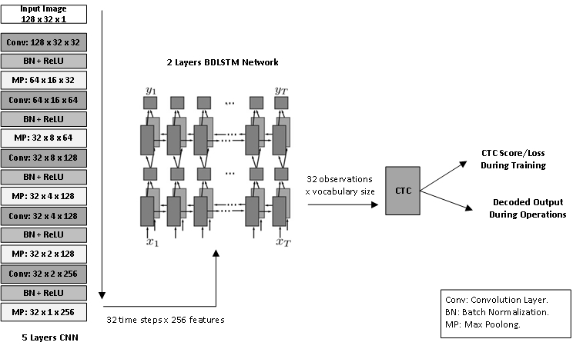
Figure 6: General architecture of the proposed model, which is comprised of (5) layers CNN, (2) layers BDLSTM and CTC loss function.

  - Processing Flow
The processing of the model starts with the CNN accepting input images of size (128×32). Once an input image is received, the CNN implements four main operations: Convolution, Batch Normalization, Activation and Max Pooling. The convolution process extracts the relevant features from the input image through the filters and passes the values to a batch normalization process to mitigate the effects of covariance shift (Sergey Ioffe and Christian Szegedy.2015). Next, ReLU activation is implemented to eliminate negative values, and the results are passed to a max-pooling layer. The max-pooling layer performs sub sampling by selecting the most relevant features and it gradually downsizes the input size into an array of size (32 time-steps×256 features). The final output of the CNN is passed to the BDLSTM network, which learns the sequence or the temporal dimension from the input. The output of the BDLSTM network is an array of size (32-observations×vocabulary size). A single character in the input text might be represented by one or more observation sequence.
A sample output of the BDLSTM network for Arabic word (al rasmeya “الرسمية”) is presented in Figures 11 (h-k) in Appendix (A). The figures demonstrate how the values for a specific output sequence increased at location that corresponds to its index in the vocabulary shown in Figure 7 below. This vocabulary represents the unique characters that are available in the custom dataset.
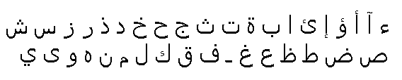
Figure 7: List of unique characters in the compiled dataset
The BDLSTM observations are passed to the CTC loss function, which performs a probabilistic based mapping between the observations and the ground-truth labels. According to our model specifications, the CTC function is able to recognize words of size (32) characters, and each time step sequence can be one of the (38) characters that were shown in Figure 7.
Finally, the CTC function computes the loss value and back propagates it to the network to initiate the end-to-end learning process. RMSOptimizer (Geoffrey Hinton.2012) was used to implement the optimization process in the proposed model.
- Experiments and Results
To train and examine the proposed model, we prepared a Python implementation using TensorFlow, this implementation is made publicly available at.The model was trained and tested using Google Colab platform. That platform provides computing environments that include acceleration hardware that can be used to train different DL models. The environment we used had the following specifications:
- Python version: 3.6.
- Tensor flow version: 2.0.
- Hardware Accelerator: 12GB NVIDIA Tesla K80 GPU.
- RAM: 12.72 GB.
- HDD: 64.4 GB.

The model was evaluated using the CRR and Words Recognition Rate (WRR) measures as shown in (1) and (2) respectively.
$$CRR=\frac{∑Levenshtein EditDistance(Recognized Text, Ground Truth)}{Total Number of Processed Characters}$$

$$WRR=\frac{Number of correctly identified words}{Total number of words}$$
In addition, the input samples were resized to (128×32) units prior to injecting them into the model because the model expects a fixed input of that size. The resizing process introduced changes on the shape of the input images, which mostly compress the image and shift the location of the text in the image. However, CNNs are shift invariance and the model can address these changes and learn features correctly. Figure 8 shows the effects of applying the resizing process on a sample word.

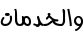 | 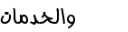
Original size: 35 x 84 | New size: 128 x 32
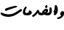 | 
Original size: 41 x 88 | New size: 128 x 32
 | 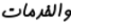
Original size: 27 x 67 | New size: 128 x 32
Figure 8: Input images before and after resizing
  - Testing Scenarios
We implemented a number of testing scenarios using the five samples sets that were presented in Table 1. The sample sets were split into train, validate, and test with a ratio of 80%, 10%, and 10% respectively.
Several testing scenarios were implemented to examine the model’s performance. The results of these testing scenarios are shown in Table 3.
Initially, the model was tested on a relatively small sample set using a single font type (i.e. sample set #1 from Table 1). The results of this test were (97.5%) for CRR and (85.18%) for WRR. Next, we tested the model on a larger dataset with the same font setting (sample set #2 in Table 1) where the CRR success rate enhanced to reach (99.04%) and the WRR achieved (94.29%). In general, the model achieved good results when it was examined on a single font type set regardless of the type or the formatting style of the tested font.
Table 3-Performance results of the model
# | Experiment Name | Dataset | Validation Accuracy % |  | Test Accuracy %
# | Experiment Name | Dataset | CRR | WRR | CRR | WRR
1 | Single font model | 1 | 98.37 | 90.28 | 97.5 | 85.18
2 | Single font model – larger dataset | 2 | 99.148 | 94.66 | 99.044 | 94.29
3 | two fonts model | 3 | 99.93 | 99.5 | 99.88 | 99.2
4 | (18) fonts, duplicate words across fonts types | 4 | 99.38 | 94.84 | 99.27 | 94.32
5 | (18) fonts, unique words across the dataset | 5 | 98.81 | 90.53 | 98.76 | 90.22
6 | Testing model generated in 5 on five character words | - | - | - | 98.71 | 92.4
7 | Testing model generated in 5 on APTI dataset – new font | - | - | - | 85.15 | 23.7
8 | Testing model generated in 5 with salt & pepper noise. | - | - | - | 82.01 | 21.48
9 | Testing model generated in 5 with salt & pepper and speckle noise. | - | - | - | 77.29 | 14.18

To examine the model’s performance on a more diverse samples set, we tested it using two font types (sample set #3 in Table 1). Using this sample set, the model achieved a CRR success rate of (99.88%) and a WRR rate of (99.2%).
The high success rates that we achieved in the previous testes encouraged us to conduct more experiments. Therefore, we decided to test the model using an extended sample set of two million words (i.e. sample set #4 in Table 1). For this experiment, our model achieved good results in CRR (99.27%) but it demonstrated a minor degradation in WRR (94.32%). This behavior can be justified because the WRR is highly dependent on the CRR and a minor flaw in the recognition of a single character affects the recognition of the related words, especially that we were testing relatively long words that have a length of (7–10 characters)
To evaluate the model more accurately in terms of overfitting, we trained it on a new sample set that has no duplication (sample set #5 in Table 1). Using this disjoint sample set, the performance of the model demonstrated a minor decrease in the reported accuracy, but it still achieved good results which were (98.76%) for CRR and (90.22%) for WRR.
To test whether our model can be generalized, we conducted an experiment on a new sample set that has words length of (5-6) characters. Although the model was not trained on this new length of words, it achieved a CRR success rate of (98.71%) and a WRR success rate of (92.4%). Obviously, this was an indication that our model can be generalized beyond the samples that were used in training the model.
In the same aspect, we carried a pilot testing for the model on the external APTI database (Fouad Slimane, Slim Kanoun, Haikal El Abed, Adel M. Alimi, Rolf Ingold, and Jean Hennebert.2013). In this experiment, we selected from this database an Arabic typesetting font of size (10). Although our model was not trained or fine-tuned on this database, it achieved a CRR success rate of (85.15%), while the WRR success rate was degraded to (23.7%). Again, this performance can also be justified by the high dependency on the CRR accuracy.
Finally, we tested the behavior of our model on some noisy datasets. For this purpose, a set of test samples were induced with salt and pepper (S&P) noise and Speckle noise transformations. Figure 9 shows a sample word before and after the noise adjustments.

Original image | Salt and Pepper noise | Salt and Pepper + Speckle noises
Figure 9: Samples images with noise adjustments
For this last experiment, our model achieved an acceptable CRR success rate of (82.01%) for the induced S&P noise, while it achieved (77.29%) for both S&P and Speckle noises. However, for the WRR success rates, the model reported (21.48%) for S&P alone and (14.18%) for both noises; S&P with Speckle. Figure 10 summarizes our model’s performance for all conducted experiments.

Figure 10: Model performance for all conducted experiments
The conducted experiments show that the model was able to achieve high accuracy results when it was trained on a specific set of fonts. This was an indication that the number of the supported fonts could be extended using the same intuitions and a more complex model with larger number of parameters. In addition, several techniques might be incorporated to enhance the WRR accuracy that has been degraded under some testing scenarios. This might include using post-processing techniques, such as language models, to enhance the overall accuracy of WRR. In addition, various image-preprocessing techniques might be used to mitigate the effects of noisy environments.
- Conclusion
In this work, we presented a hybrid DL model for recognizing Arabic text in images. The objective of the work was to examine the models competency in recognizing Arabic text that was printed using multiple font types, including fonts that mimic Arabic handwriting script. The model demonstrated good CRR in most testing scenarios including the testing on a disjoint samples sets, the testing on a pilot external database and the testing under noisy environments. The overall performance of the model is open for more enhancements through incorporating language models to enhance the overall WRR accuracy as well as using image processing techniques to mitigate the effects of noise in images. Such measures might be investigated in a future work.
References
[1] Hanan Alahmad Bodour Alreha,Najla Alsaedi. 2020. Historical Arabic Manuscripts Text Recognition Using Convolutional Neural Network. Conf. Data Sci. Mach. Learn. Appl. Hist. (2020).
[2] Ali Mohsin and Mohammed Sadoon. 2019. Developing an Arabic Handwritten Recognition System by Means of Artificial Neural Network. J. Eng. Appl. Sci. 15, 1 (2019), 1–3. DOI:https://doi.org/10.36478/jeasci.2020.1.3
[3] Muhammad Kashif Siddhu and Shahrul Nizam Yaakob. 2019. Deep learning applied to arabic and latin scripts: A review. Int. J. Sci. Technol. Res. 8, 11 (2019), 1510–1521.
[4] Mansoor Alghamdi and William Teahan. 2018. Printed Arabic script recognition: A survey. Int. J. Adv. Comput. Sci. Appl. 9, 9 (2018), 415–428. DOI:https://doi.org/10.14569/ijacsa.2018.090953
[5] LS Alhomed and KM Jambi‏. 2018. A Survey on the Existing Arabic Optical Character Recognition and Future Trends‏. Int. J. Adv. Res. Comput. Commun. Eng. 7, 3 (2018), 78–88. DOI:https://doi.org/10.17148/IJARCCE.2018.7213
[6] Mohit Jain, Minesh Mathew, and C. V. Jawahar. 2018. Unconstrained OCR for Urdu using deep CNN-RNN hybrid networks. Proc. - 4th Asian Conf. Pattern Recognition, ACPR 2017 (2018), 753–758. DOI:https://doi.org/10.1109/ACPR.2017.5
[7] Abdelhay Zoizou, Arsalane Zarghili, and Ilham Chaker. 2018. A new hybrid method for Arabic multi-font text segmentation, and a reference corpus construction. J. King Saud Univ. - Comput. Inf. Sci. (2018). DOI:https://doi.org/10.1016/j.jksuci.2018.07.003
[8] Hazem EL-Bakry Ahmed El-Sawy, Mohamed Loey. 2017. Arabic Handwritten Characters Recognition using Convolutional Neural Network. WSEAS Trans. Comput. Res. 5 (2017), 11–19. DOI:https://doi.org/10.1109/IACS.2019.8809122
[9] Andreas Dengel Riaz Ahmad, Saeeda Naz, Muhammad Afzal, Sheikh Rashid, Marcus Liwicki. 2017. A Deep Learning based Arabic Script Recognition System. Int. Arab J. Inf. Technol. October (2017).
[10] Ashraf A. Shahin. 2017. Printed Arabic Text Recognition using Linear and Nonlinear Regression. Int. J. Adv. Comput. Sci. Appl. 8, 1 (2017), 227–235. DOI:https://doi.org/10.14569/ijacsa.2017.080129
[11] Khaled Younis and Abdullah Khateeb. 2017. Arabic Hand-Written Character Recognition Based on Deep Convolutional Neural Networks. Jordanian J. Comput. Inf. Technol. 3, 3 (2017), 186. DOI:https://doi.org/10.5455/jjcit.71-1498142206
[12] Chen Yu Lee and Simon Osindero. 2016. Recursive Recurrent Nets with Attention Modeling for OCR in the Wild. Proc. IEEE Comput. Soc. Conf. Comput. Vis. Pattern Recognit. 2016-Decem, 3 (2016), 2231–2239. DOI:https://doi.org/10.1109/CVPR.2016.245
[13] Sergey Ioffe and Christian Szegedy. 2015. Batch normalization: Accelerating deep network training by reducing internal covariate shift. 32nd Int. Conf. Mach. Learn. ICML 2015 1, (2015), 448–456.
[14] Aboul Ella Hassanien, Mohamed F. Tolba, and Ahmad Taher Azar. 2014. Isolated Printed Arabic Character Recognition Using KNN and Random Forest Tree Classifier. Commun. Comput. Inf. Sci. 488, November (2014), 10–17. DOI:https://doi.org/10.1007/978-3-319-13461-1
[15] Marwan Torki, Mohamed E. Hussein, Ahmed Elsallamy, Mahmoud Fayyaz, and Shehab Yaser. 2014. Window-Based Descriptors for Arabic Handwritten Alphabet Recognition: A Comparative Study on a Novel Dataset. Retrieved from http://arxiv.org/abs/1411.3519
[16] Faten Kallel Jaiem, Slim Kanoun, Maher Khemakhem, Haikal El Abed, and Jihain Kardoun. 2013. Database for Arabic printed text recognition research. Lect. Notes Comput. Sci. (including Subser. Lect. Notes Artif. Intell. Lect. Notes Bioinformatics) 8156 LNCS, PART 1 (2013), 251–259. DOI:https://doi.org/10.1007/978-3-642-41181-6_26
[17] Fouad Slimane, Slim Kanoun, Haikal El Abed, Adel M. Alimi, Rolf Ingold, and Jean Hennebert. 2013. ICDAR2013 competition on multi-font and multi-size digitally represented arabic text. Proc. Int. Conf. Doc. Anal. Recognition, ICDAR August (2013), 1433–1437. DOI:https://doi.org/10.1109/ICDAR.2013.289
[18] Irfan Ahmed, Sabri A Mahmoud, and Mohammed Tanvir Parvez. 2012. Guide to OCR for Arabic Scripts. Guid. to OCR Arab. Scripts November 2017 (2012). DOI:https://doi.org/10.1007/978-1-4471-4072-6
[19] Geoffrey Hinton. 2012. Neural Networks for Machine Learning - Lecture 6a - Overview of mini-batch gradient descent. (2012). DOI:https://doi.org/10.1017/9781139051699.031
[20] Sabri A. Mahmoud, Irfan Ahmad, Mohammad Alshayeb, Wasfi G. Al-Khatib, Mohammad Tanvir Parvez, Gernot A. Fink, Volker Märgner, and Haikal El Abed. 2012. KHATT: Arabic offline Handwritten Text Database. Proc. - Int. Work. Front. Handwrit. Recognition, IWFHR (2012), 449–454. DOI:https://doi.org/10.1109/ICFHR.2012.224
[21] Harald Scheidl. 2011. Handwritten Text Recognition in Historical Documents. Retrieved from http://www.ub.tuwien.ac.athttp//www.ub.tuwien.ac.at/eng
[22] Amin G. Al-Hashim and Sabri A. Mahmoud. 2010. Benchmark database and GUI environment for printed arabic text recognition research. WSEAS Trans. Inf. Sci. Appl. 7, 4 (2010), 587–597.
[23] Alex Graves. 2008. Offline Arabic Handwriting Recognition with Multidimensional Recurrent Neural with Multidimensional Recurrent Neural Networks. Adv. Neural Inf. Process. Syst. January 2008 (2008). DOI:https://doi.org/10.1007/978-1-4471-4072-6
[24] W J L Adams and D L Saaty. 2006. Connectionist temporal classification: Labelling unsegmented sequence data with recurrent neural networks. (2006). DOI:https://doi.org/10.1145/1143844.1143891
[25] Mario Pechwitz, Samia Snoussi, and Noureddine Ellouze. 2002. IFN / ENIT-database of handwritten Arabic words. May 2014 (2002).
[26] R Davidson, R., Hopely. 1997. Arabic and Persian Training and Test Data Sets. In Proceedings of Symposium. On Document Image Understanding Technology.
[27] Sepp Hochreiter and Jürgen Schmidhuber. 1997. Long Short-Term Memory. Neural Comput. 9, 8 (1997), 1735–1780. DOI:https://doi.org/10.1162/neco.1997.9.8.1735
[28] Mike Schuster and Kuldip K. Paliwal. 1997. Bidirectional recurrent neural networks. IEEE Trans. Signal Process. 45, 11 (1997), 2673–2681. DOI:https://doi.org/10.1109/78.650093

https://drive.google.com/drive/folders/1mRefmN4Yzy60Uh7z3B6cllyyOXaxQrgg?usp=sharing
https://github.com/JTCodeStore/TextIimagesToolkit
https://github.com/JTCodeStore/ArabicDLOCR

